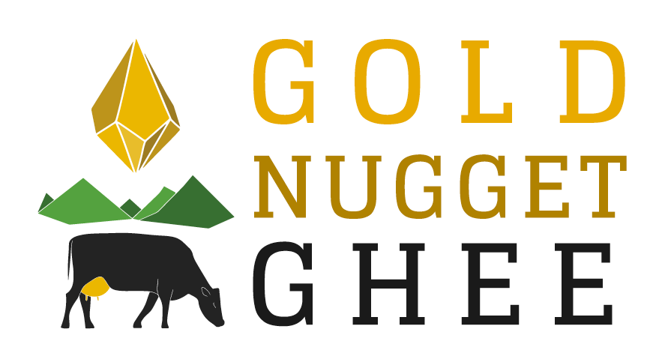
100 Ericson Court. Arcata, CA 95521
(562) 453-5527 www.goldnuggetghee.com

Wholesale Price List

UPC | Product Number | Description | Suggested Retail Price | Unit Price
866430000214 | #1001 | 8 oz jar (Original) | $13.99 | $8.39
866430000221 | #1002 | 16 oz jar (Original) | $23.99 | $14.39
866430000238  866430000245  866430000252  866430000269 | #1003  #2001  #2002  #2003 | 32 oz jar (Original)  8 oz (Chocolate Honey)  16 oz (Chocolate Honey)  32 oz (Chocolate Honey) | $42.99  $15.99  $26.99  $46.99 | $25.79  $9.59  $16.19  $28.19

Minimum orders are for three cases (18 units).

Case price (before S&H):
Original
8oz---- $50.34
16oz--- $86.34
32oz--- $154.74
Chocolate Cardamom
8oz --- $57.54
16oz--- $97.14
32oz--- $169.14

Shipping will be done through:
USPS Priority Mail/ UPS
Make checks payable to:
Gold Nugget Ghee

